# A

**Project Report On**

“Jobsters- Get We Known”

# Submitted in Partial Fulfillment for Award of Degree

**Of**

**Master of Computer Applications Semester VI**

Gaurav K. Lohar (175303693016)

Ghanshyam Prajapati (175303693008)

**Internal Guide Dr.**

Dr. Amisha Shingala (SVIT)

**SARDAR VALLABHBHAI PATEL INSTITUTE OF TECHNOLOGY (SVIT), VASAD**

**Affiliated To**

**Gujarat Technological University (GTU)**

**April**

**Chapter 1: Introduction: -**

* 1. **.Problem Summary and Introduction: -**
* As nowadays demand for restaurant food is increasing. The youngsters and elders love to go to restaurants and enjoy the food. But as we know that there is a long waiting (especially during special occasions) to acquire a table in restaurant and having the food at our table.
* So, here our aim is to resolve these problems through our system or application by booking a table in any restaurant from anywhere and can also order their meal in advance. (Main motto: TIME SAVING). Also, an alert message facility is provided if vacant table available before booked timings.
* We will use ML concepts for recommendation of top picks through the analysis of customer’s liking history. We will also provide the view of tables so people can book tables according to their likings and privacy.
* Our product is very beneficial in this COVID-19 pandemic as there won’t be waiting and rush to acquire a table in restaurant and so social distancing is followed.

**1.2. Sodh Yatra: -**

1) How do we find our definition on project?

* + By discussing amongst ourselves and with friends and relatives, we get to know the real time problem faced by people regarding the restaurant long waiting especially on occasions and functions.
  + Thus, we selected this definition.

2) To whom we contacted for project definition?

* + We talked with few Restaurant Managers of different restaurants and we opted the project by knowing the problems faced by their customers and their staff as well and we will try to resolve them all.

3) What are the data or information we collected?

* Both the customers and restaurants told us about the issues of waiting queue for table reservation and managing the queue respectively.
* Due to long waiting, social distancing is not being followed so customers avoid going much in restaurants and so the restaurants are also at loss.

4) What are the problems people(customers) are facing?

* As there is increasing demand for restaurant food but there is a big queue and customers have to wait for table to be vacant and even after acquiring the table, they have to wait for the food to be served at their table so this results into their time waste.
* As far as the current situation of COVID-19 is concerned, people are not able to follow “social distancing” due to rush at restaurants. So, it is also a big problem nowadays for both customers and restaurants.

5) What are the solutions be provided by our project to overcome the problems faced by people?

* **(Main motto: TIME SAVING)**

->Advance Restaurant and Table Booking.

->Prior Menu Ordering.

**1.3. Aim and objectives of the project: -**

* The scope of Jobsters is to give the opportunity to the candidate to reach the organization and the organization can recruit knowledgeable candidates in fewer efforts.
* The Jobsters are cutting off the time which spends by the organization to manage the whole day after recruitment activities.
* The candidate can easily find vacancies of a particular organization and give them a test of particular subjects. And if that candidate passes the test, then they can upload his resume.

**1.4 .Problem Specifications: -**

* ‘Jobsters Get We Known’ candidate is using online website for get Jobs, the particular company for give online test (Exam) and upload resume.
* The company is get resume for candidate resume forget high score in test to easy to select company.

**1.5. Work Plan (Timeline chart/ Gantt Chart): -**

## 

## 

**Chapter 2: Requirement Specification: -**

**2.1. Functional Requirement: -**

* Registration/Login and Profile: View Profile, Edit Profile , View Order History
* Table Booking and Menu Ordering: View Table Layout and book table according to their convenience . View menu and place order in advance
* Take away: Order status
* Payment
* Management System: Admin will manage customers and restaurant account. Also provide help regarding our app working issues if needed.
* Reviews and Ratings

**2.2. Non-Functional Requirement**: -

1. **Security**

* Admin has highest authority to manage customers and restaurants.
* Restaurant has the authority for managing the orders.
* Users can view booked order detail and take a report of that.
* Passwords should be stored in encrypted form.

1. **Usability**

* The navigation in the app will be user-friendly i.e. table layout, menus and each and every detail will be presented in a simple way.

1. **Reliability**

* Our app will be available for users but in some maintenance days, it will not be available. Data validation and verification need to be done whenever required at any stage of activity.
* Validating user input.

1. **Performance**

* Our app will not take longer than 10 seconds to respond to a request, when using 3G or 4G Internet connection.

1. **Supportability**

* Our app will be supportable in every android mobiles.

1. **Safety Requirement**

* The database may get crashed at any certain time due to viruses or operating system failures. Therefore, it is required to take the database backup.

1. **Interface**

* Our application will accessible through any android mobile.

**2.3. System Requirements: -**

**2.4. Hardware Requirement: -**

* **Smart phone/tablet**

Secondary Storage: 4 GB (Minimum)

RAM: 2 GB(Minimum)

* **Computer/laptop**

Secondary Storage: 100 GB

RAM: 2 GB(Minimum)

**2.5. Software Requirement: -**

* Android Studio 3.0.1
* MySQL 5.6.12
* PHP 5.4.16
* Sublime Text
* XAMPP Server

**2.6. Feasibility Study: -**

* A feasibility study is an analysis that takes all of the projects relevant factors into account including economic, technical, legal, scheduling considerations – to ascertain the likelihood of completing the project successfully.

**2.6.1. Technical Feasibility: -**

The technical feasibility is worked for the project is done with the present equipment, manual procedures, existing   software technology and available technical hardware. This assessment focuses on the technical resources available to the organization. Technical feasibility also involves the evolution of the hardware, software, and other the technical requirements of the proposed system.

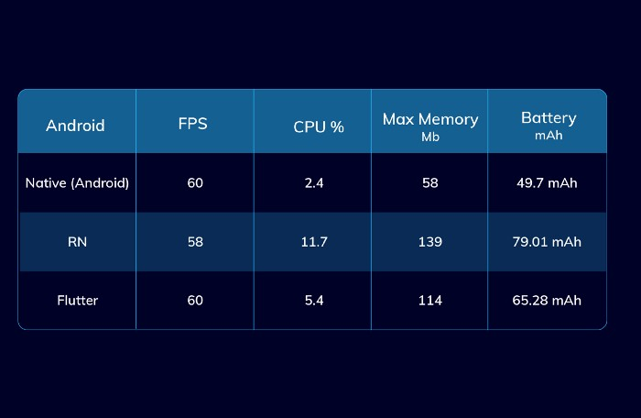

For Loading and Caching Images

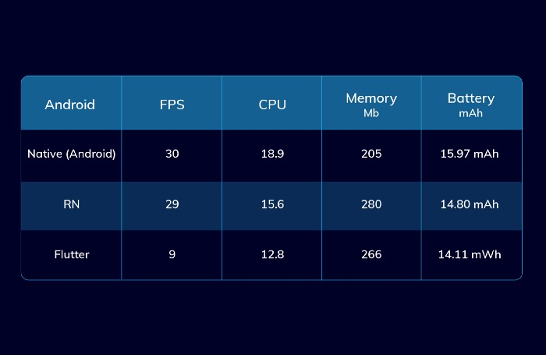

For Heavy Animation

**2.6.2. Operational Feasibility: -**

**2.6.3. Economic Feasibility: -**

* This assessment typically involves a cost/benefits analysis of the project, helping the organization determine the viability, cost, and benefits associated with a project before financial resources are allocated. The proposed system economically feasible as it removes manual work, reduces the manual mistake, decreases the number of people working. Economic feasibility is the system where the users have economic to this system the agency has to provide the required software.

**2.7. System Limitation (In which condition/ environment system will not work): -**

**Chapter 3 : System Design: -**

**3.1. System Architecture (Block diagram): -**

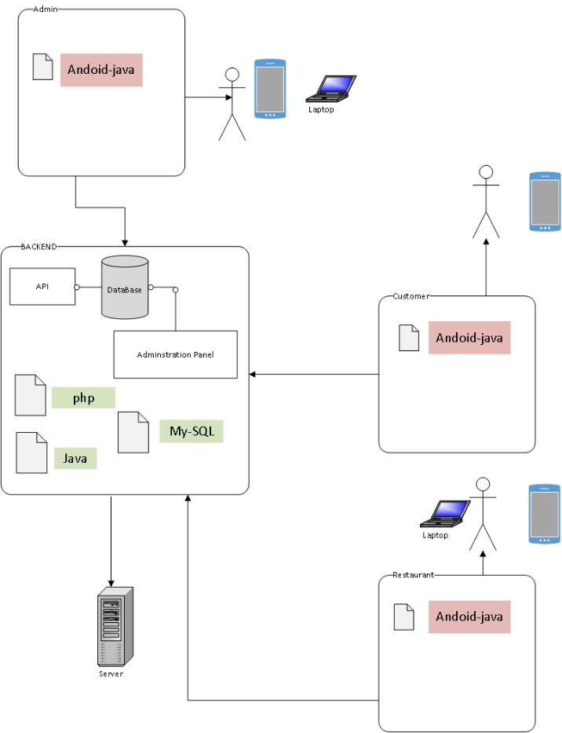

**3.2. System Diagrams: -**

**3.2.1. Class Diagram: -**

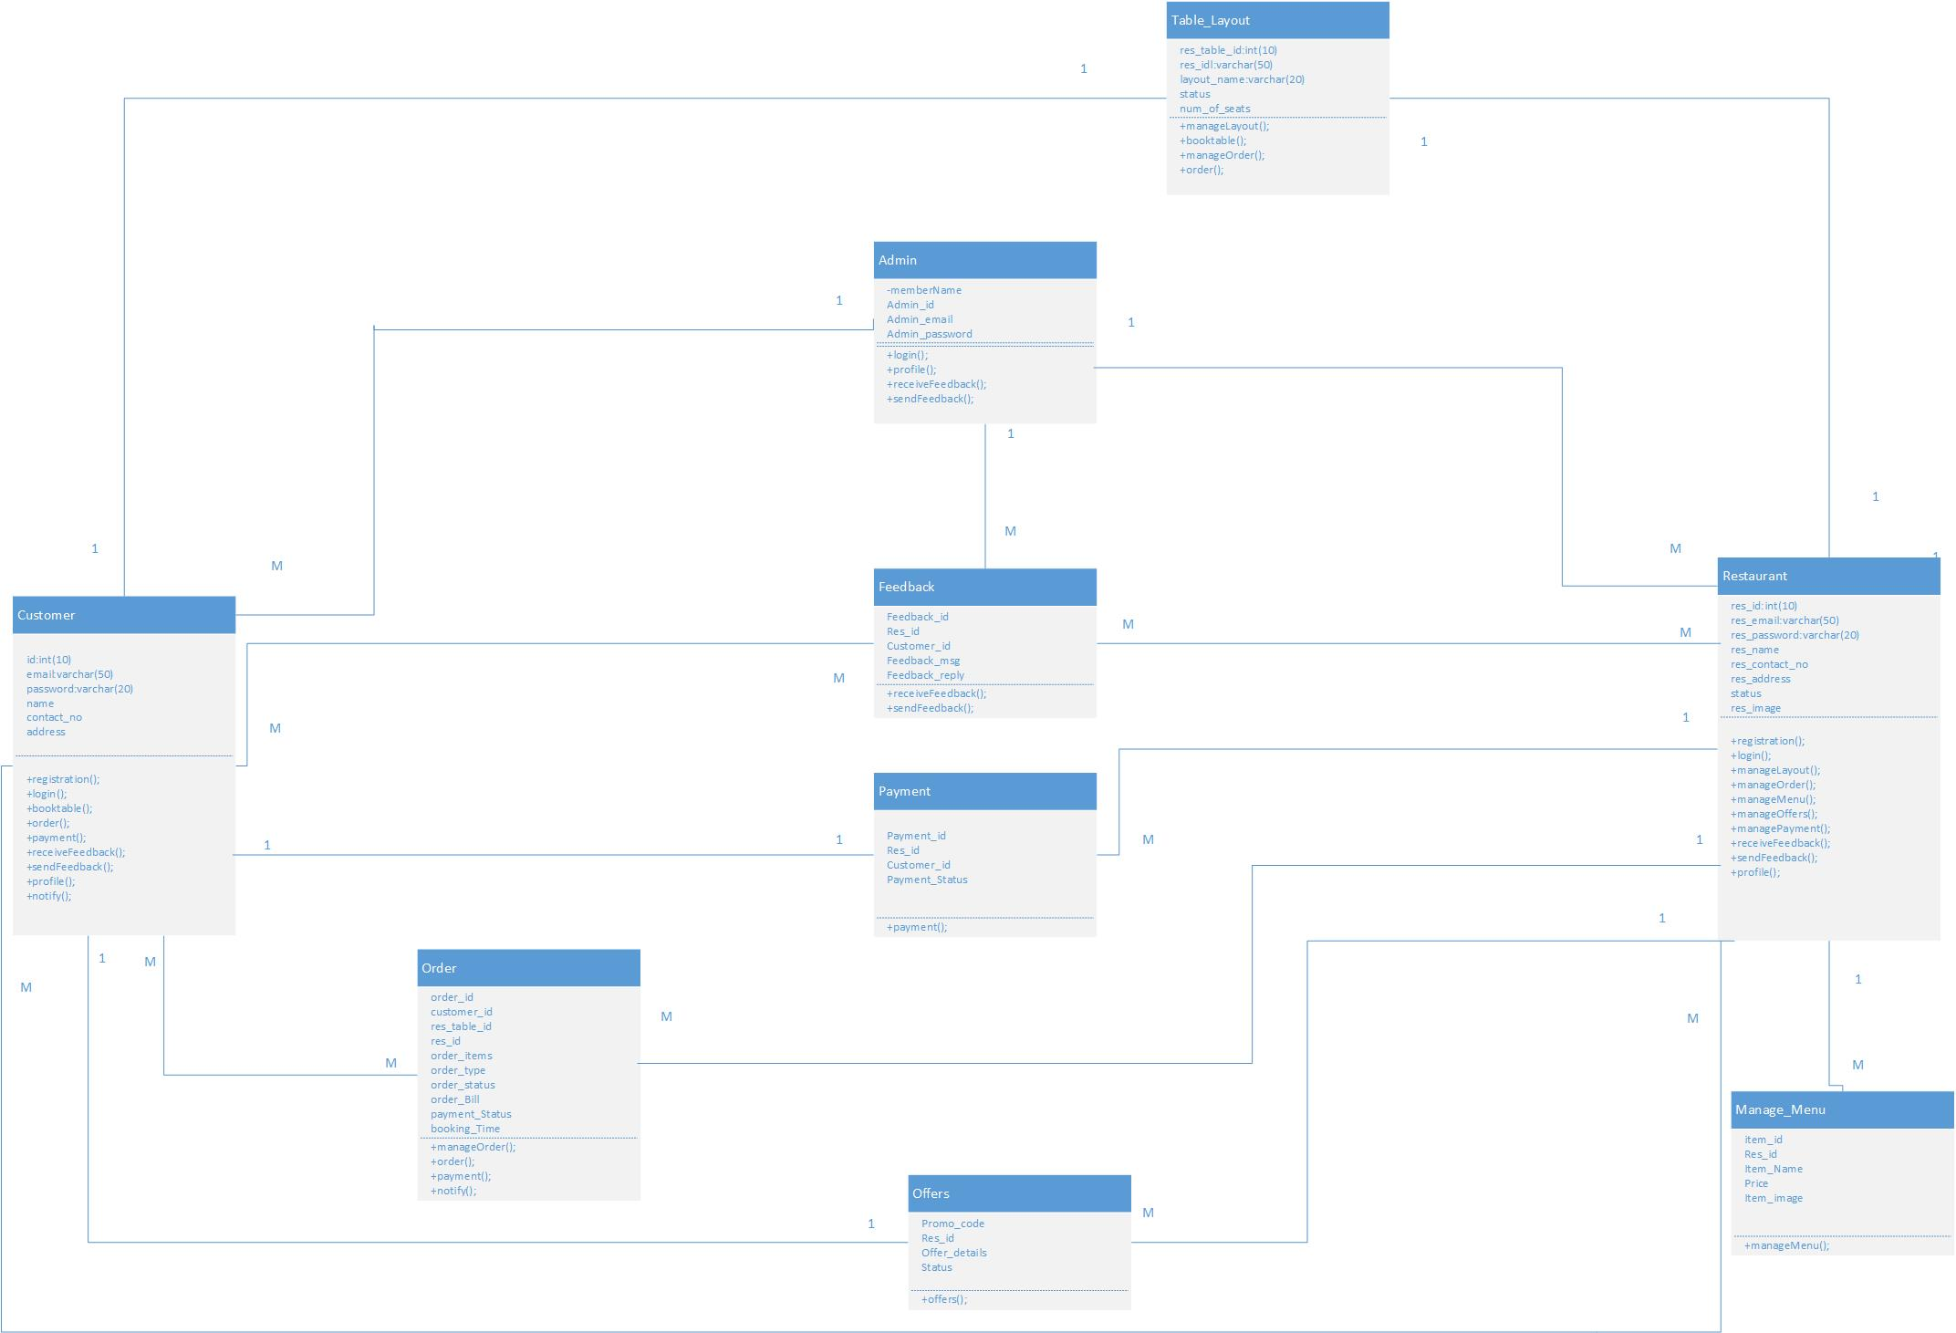

**3.2.2. Use Case: -**

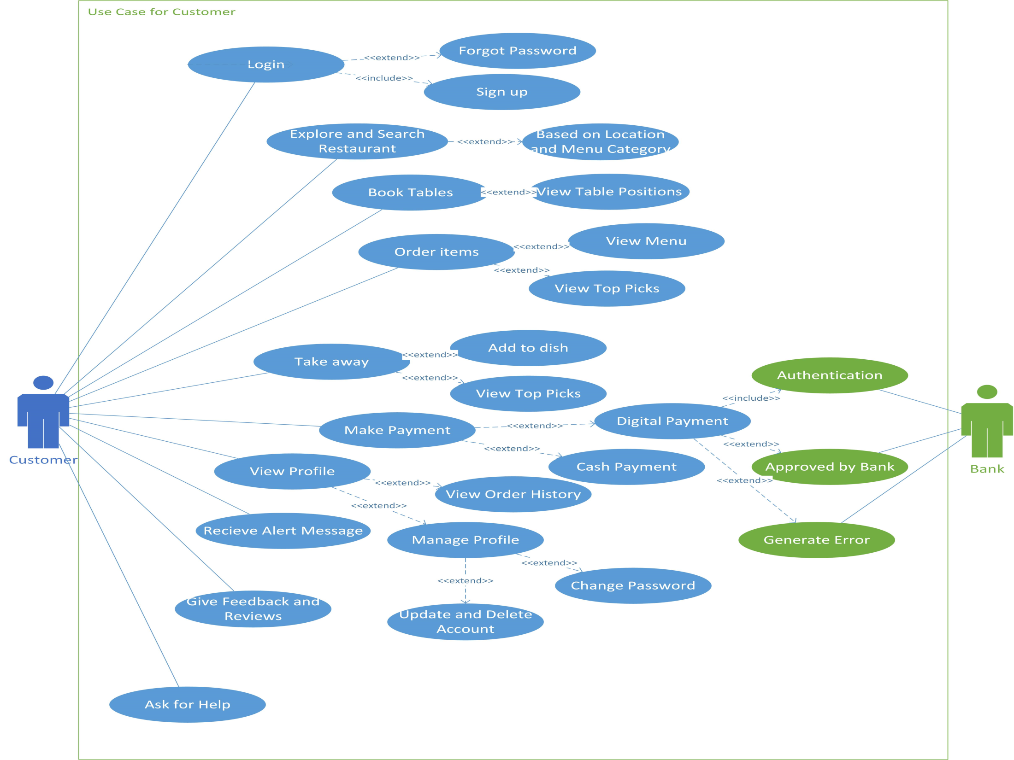



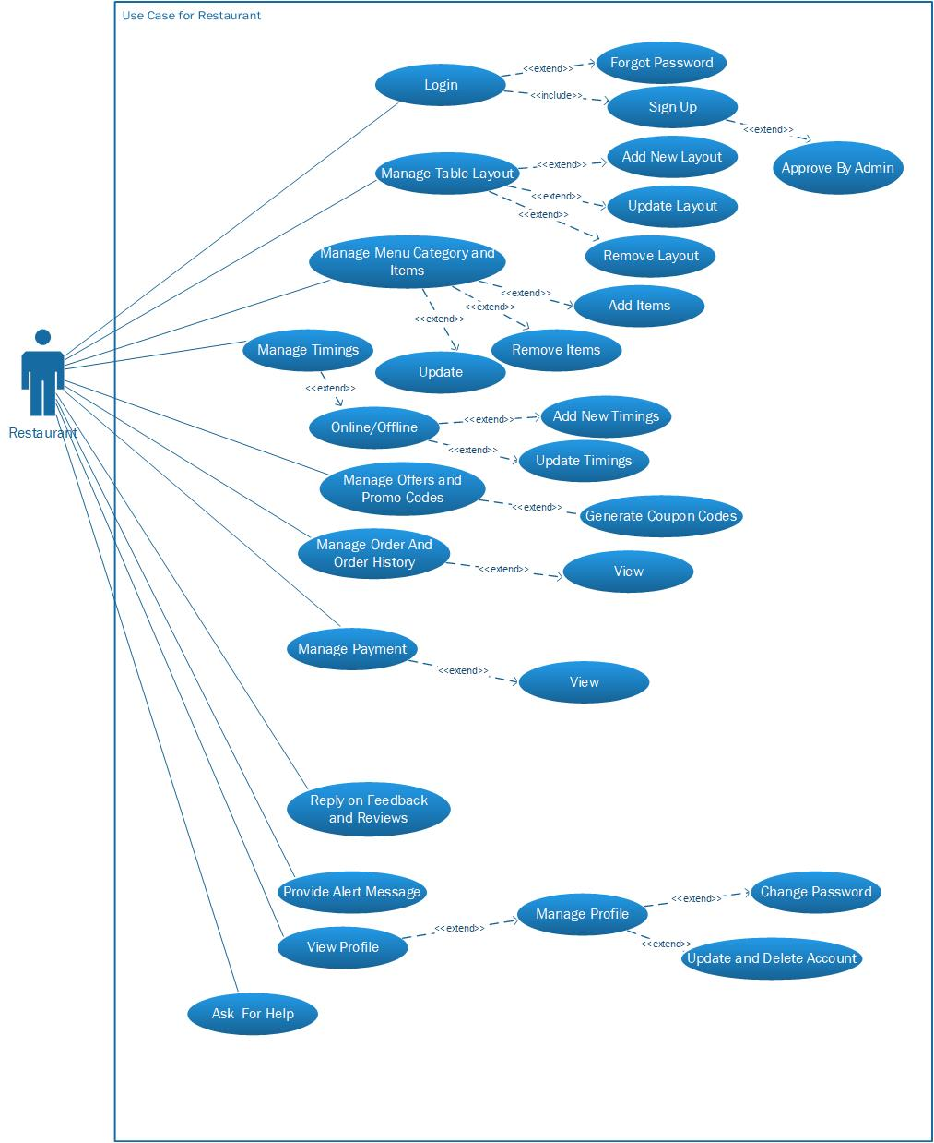

**3.2.3. Activity: -**

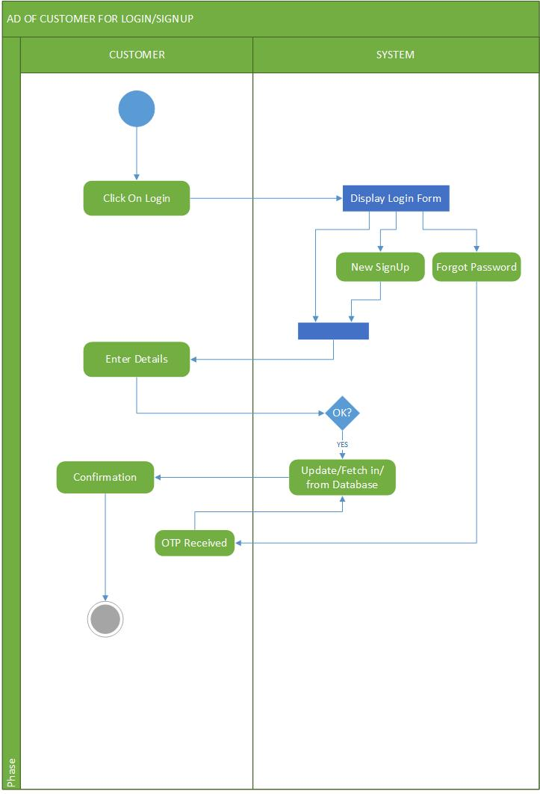

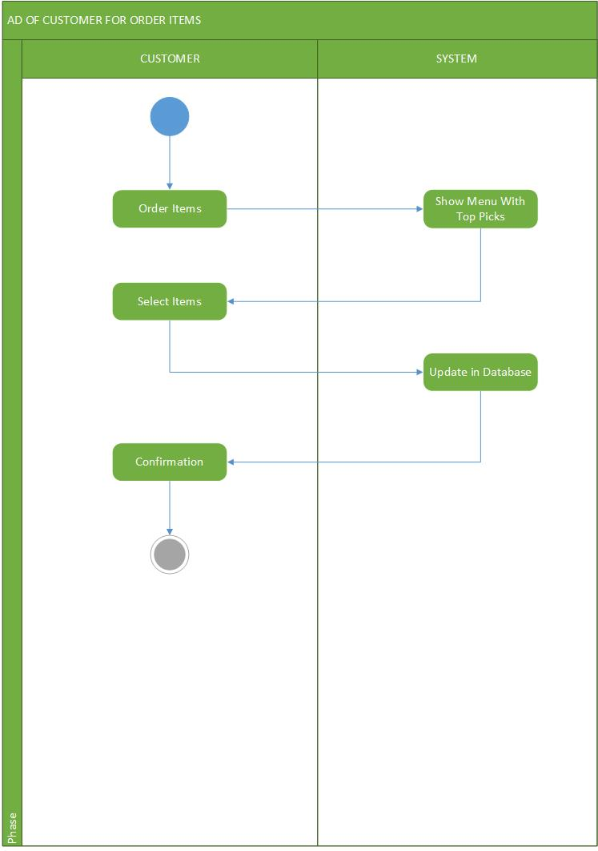

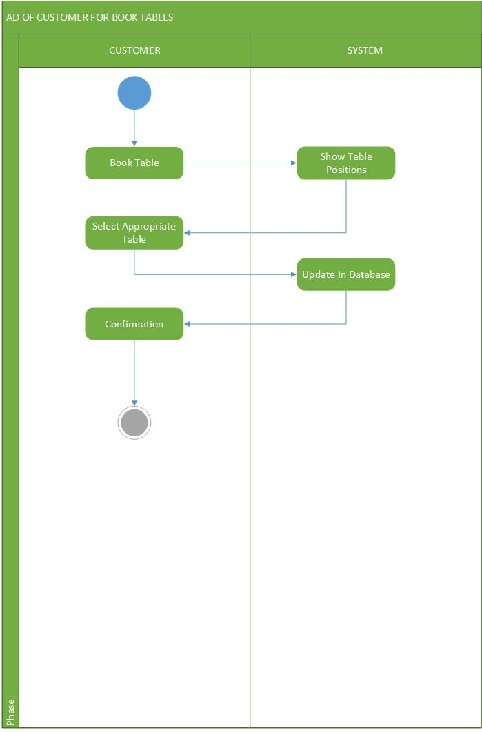

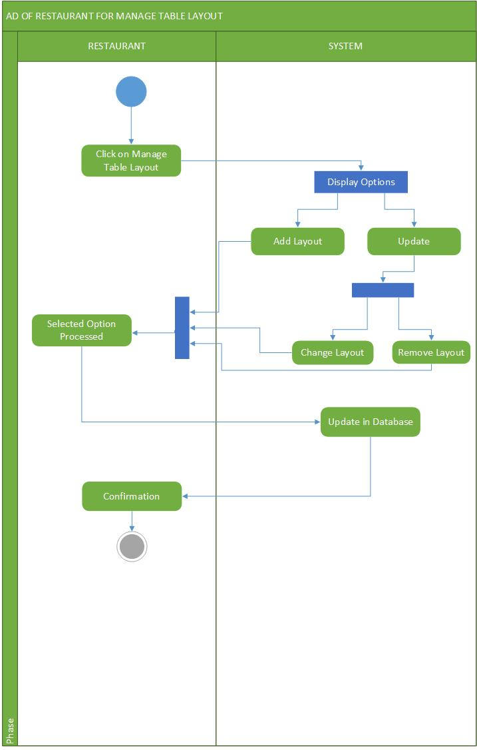

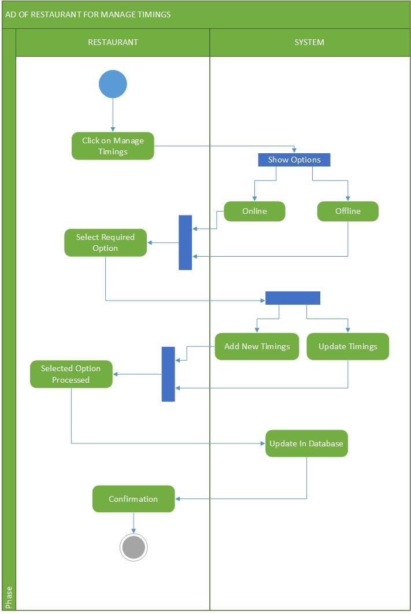

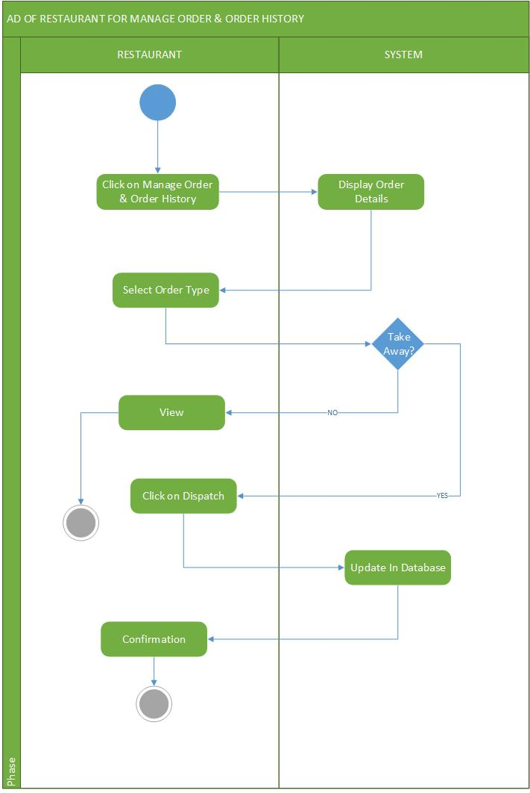

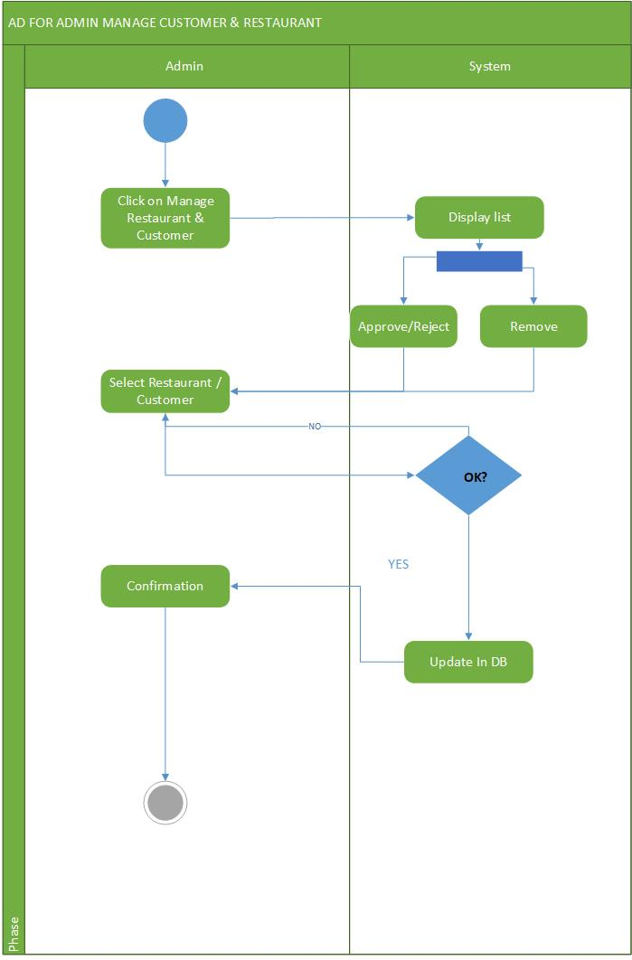

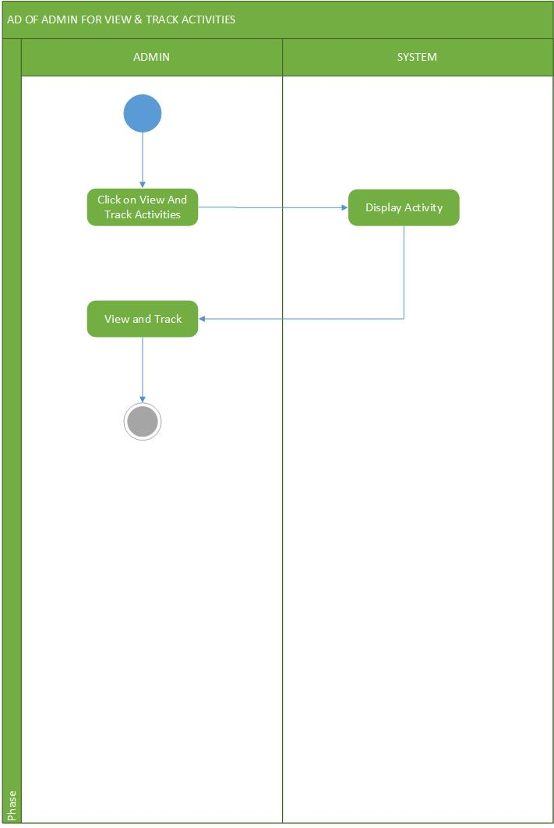

**3.2.4. Sequence Diagram: -**

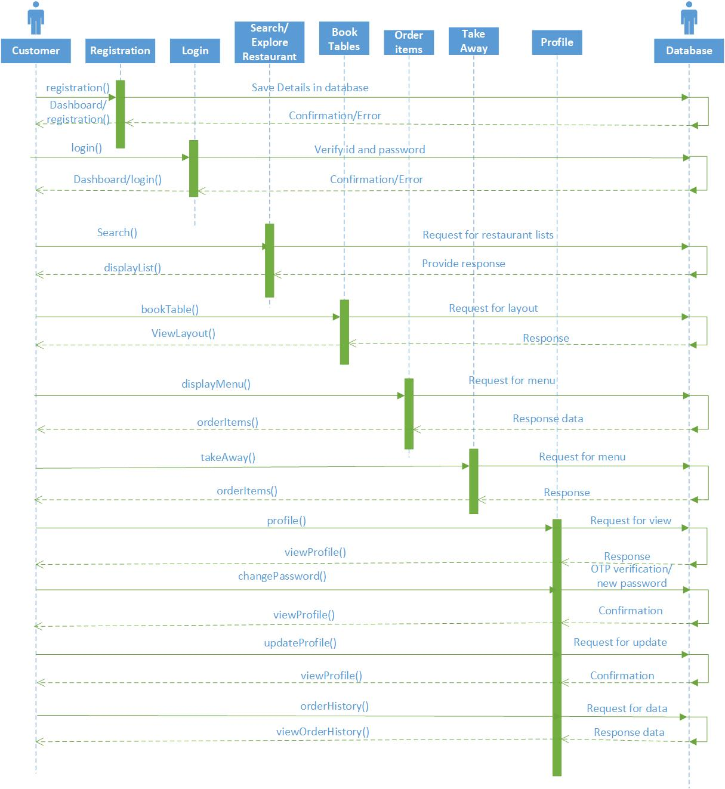

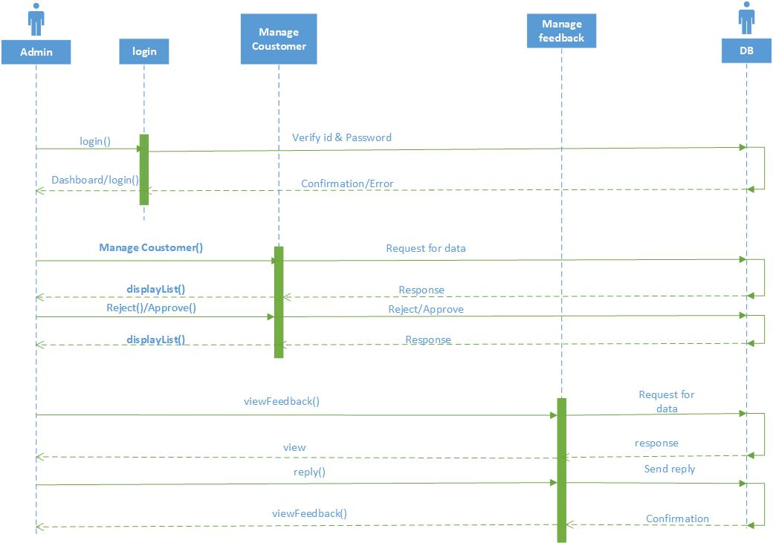

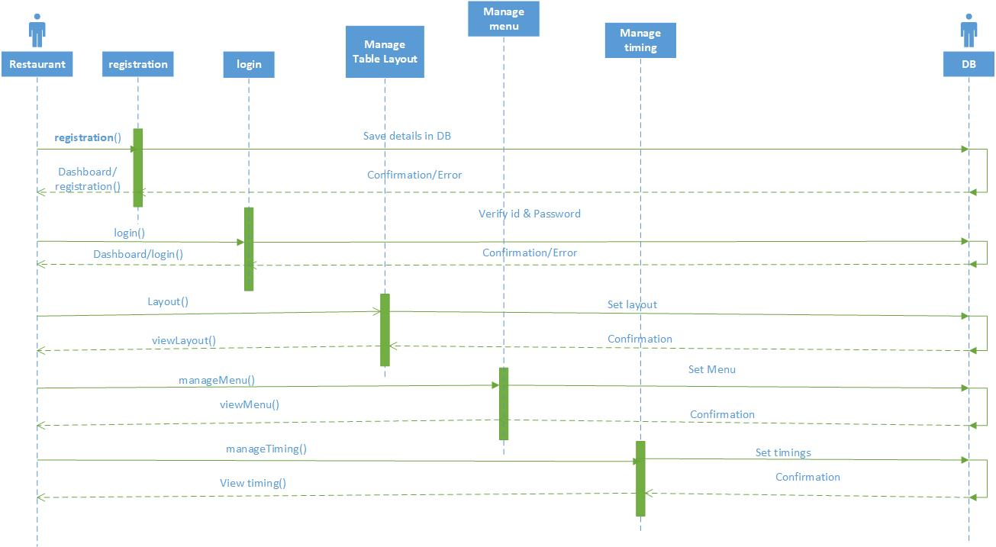

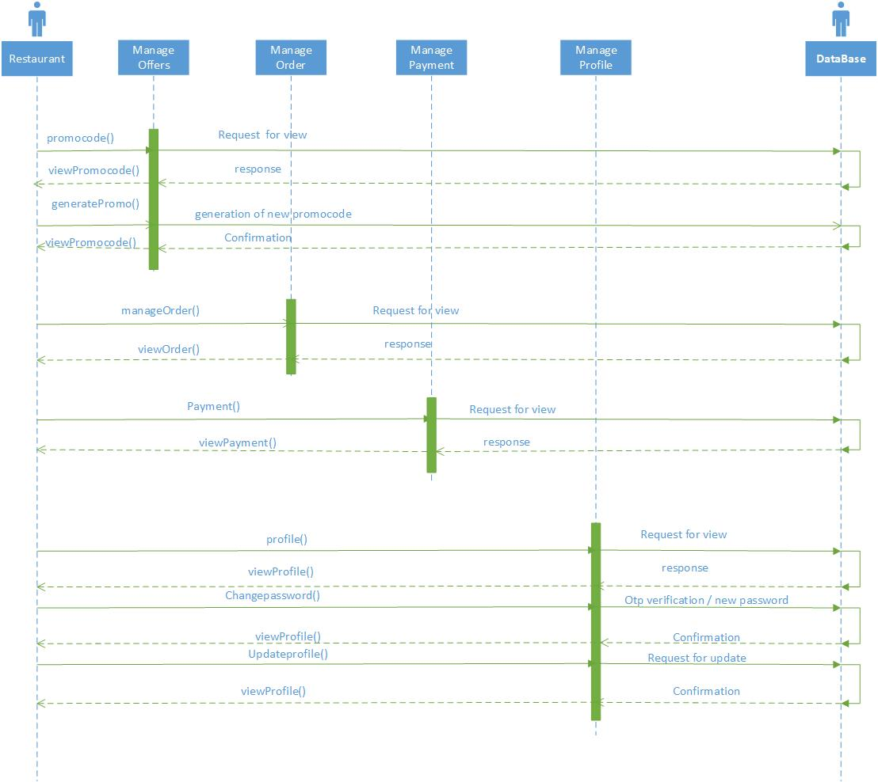

**3.3. Database Design: -**

**3.3.1. E-R Diagram: -**

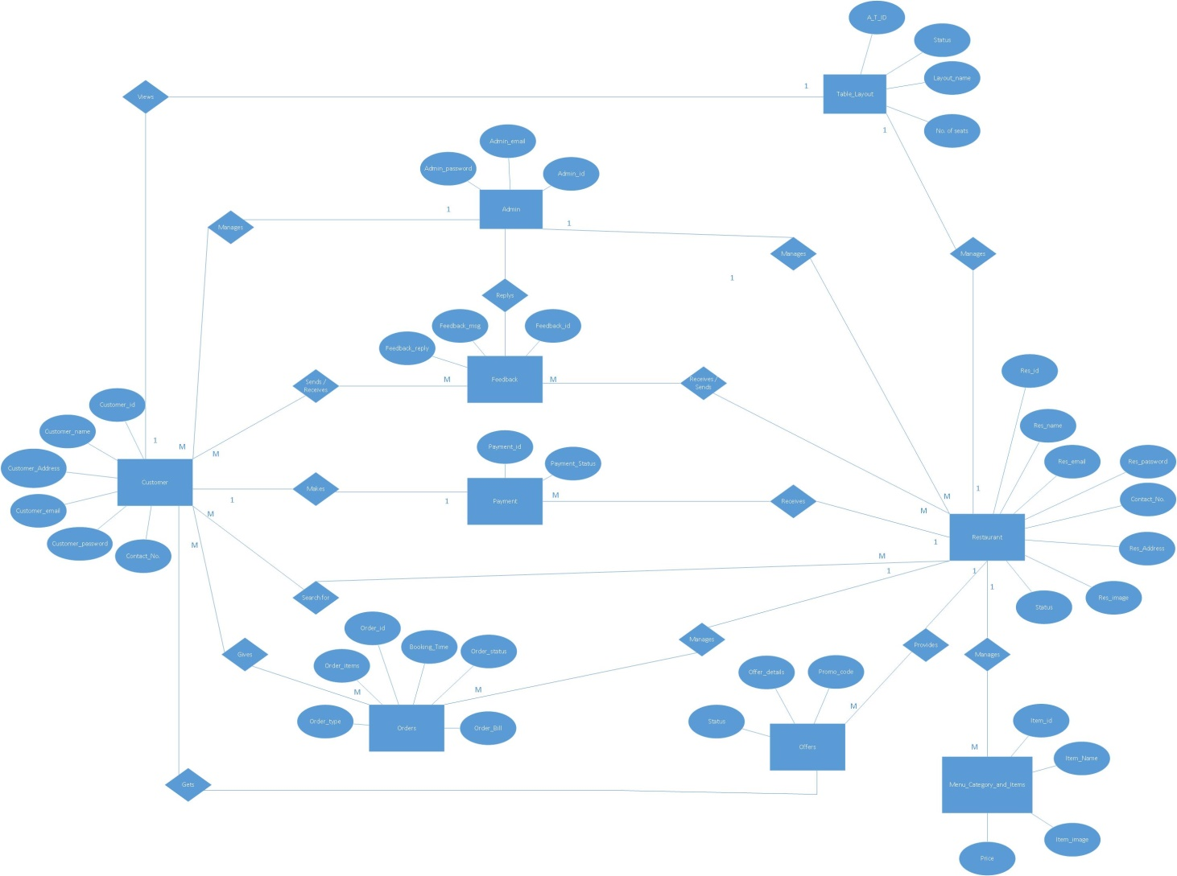

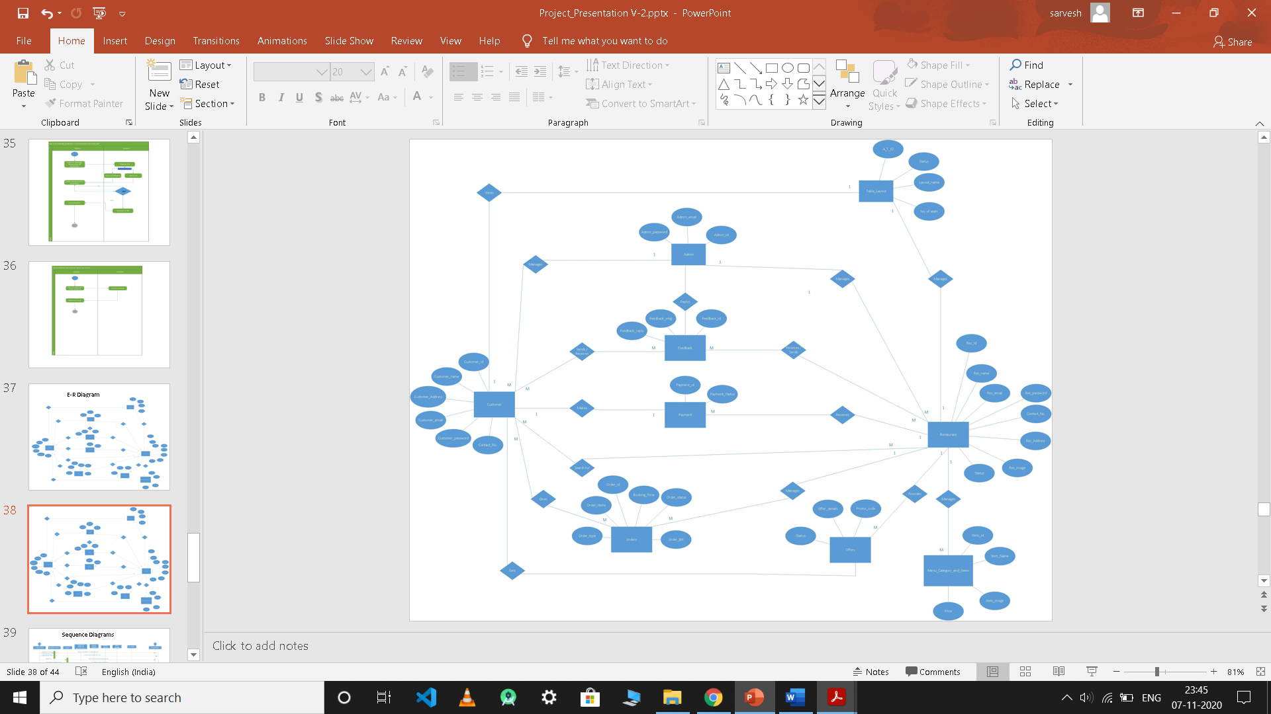

**3.3.2. Data Dictionary: -**

## 

## 

## 

## 

## 